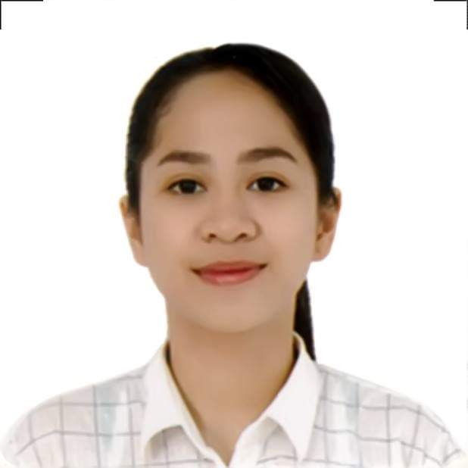Marinella Castuera

2272 Tejeron St. Sta. Ana Manila | 09073830214 | [castuera.m.bsinfotech@gmail.com](mailto:castuera.m.bsinfotech@gmail.com)

# Objective

I want to succeed in a stimulating and challenging environment, building the success of the company while I experience advancement opportunities.

# EDUCATION

Tertiary - **Eulogio Amang Rodriguez Institute of Science and Technology**

**Bachelor of Science in Information Technology**

June 2018 – Present

Senior High - **Philippine Christian University**

**Information Communication Technology**

June 2016 – March 2018  
Junior High **- Mariano Marcos High School**  
June 2012 – March 2016

# SKILLS

* Keen to details
* Problem-solving Skills
* C**apable of exercising ethical judgement and integrity**

# EXPERIENCE

**BLVD Work Solutions Corporation**

**LBC Customer Associate** | July 13, 2020 – December 13, 2020

* Maintains customer relationship by responding to inquiries; documenting actions.
* Prepares for customer inquiries by studying products, services, and customer service processes etc..

# AComplishments

* Graduated Senior High as Honorable Student
* Graduated Junior High as 1st Honor Student in Class